Stage 1.1: Provision Model

- Go to https://ai.azure.com, you should already be logged in. If not log in gain with your credentials for this workshop

- At the home page, click on “Create New”

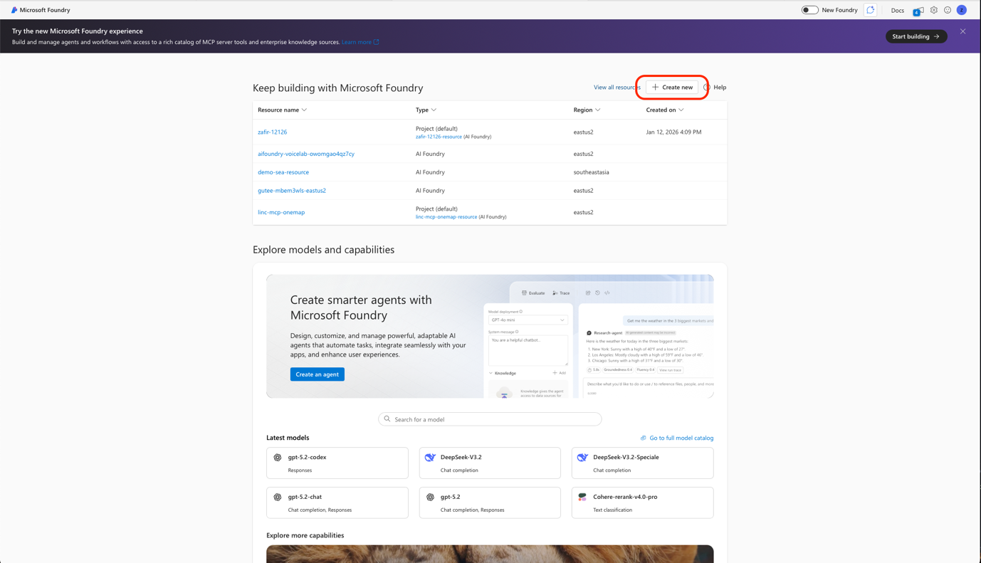

- Select “Microsoft Foundry Resource” and click next

- Name the resource with your preferred name. Important: Ensure the resource group your project is created is in the same resource group as the one created for you for this session (Check with your facilitators if unsure).
Region: Southeast Asia
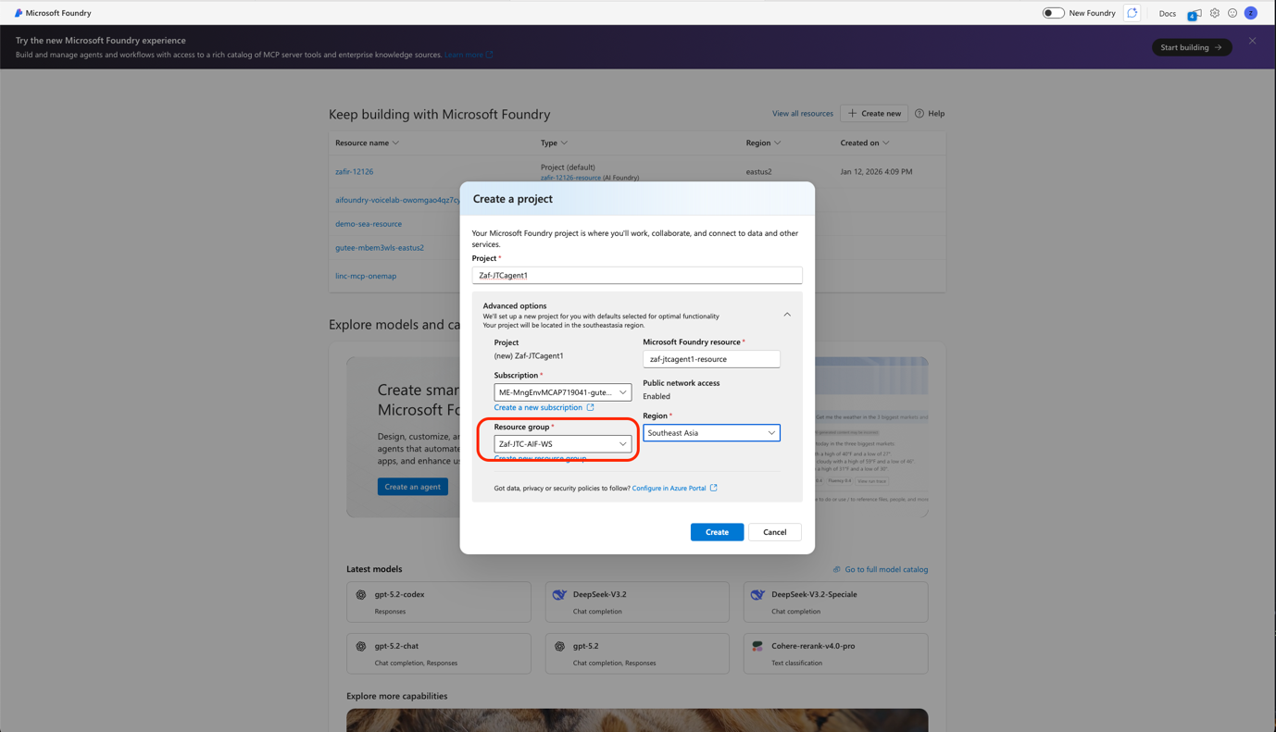

- Once your agent is provisioned, you will see the page below. Click on “Agents” on the side pane.
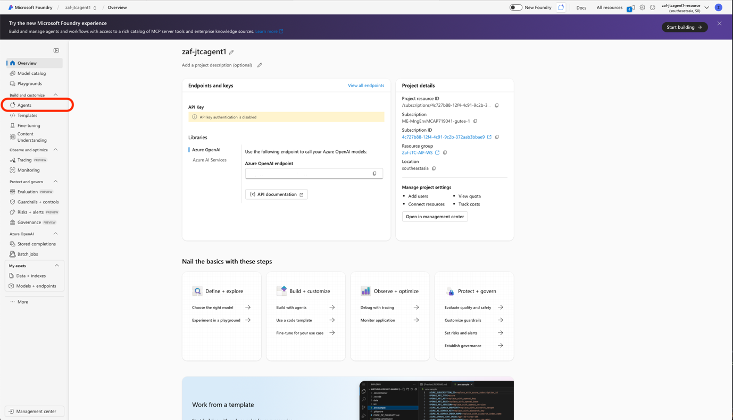

- You will be greeted with a pop up window. This is where you can see all the models that you can deploy for your AI solution. For this session, Select “gpt-4o” and click “Confirm”
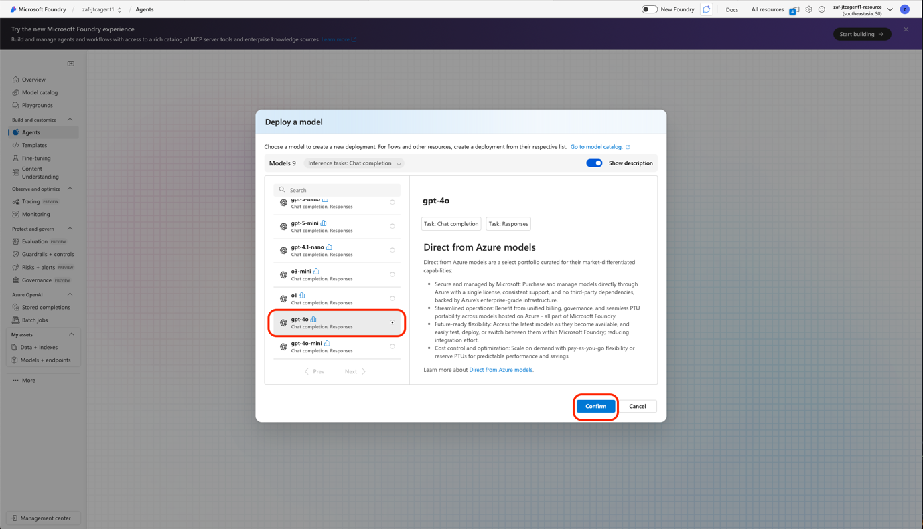

- In the pop-up window, let deployment type be “Global Standard” and click “Deploy”

- You will see the model deployed with a random name. Click on the name and edit it to “Vendor Scout”

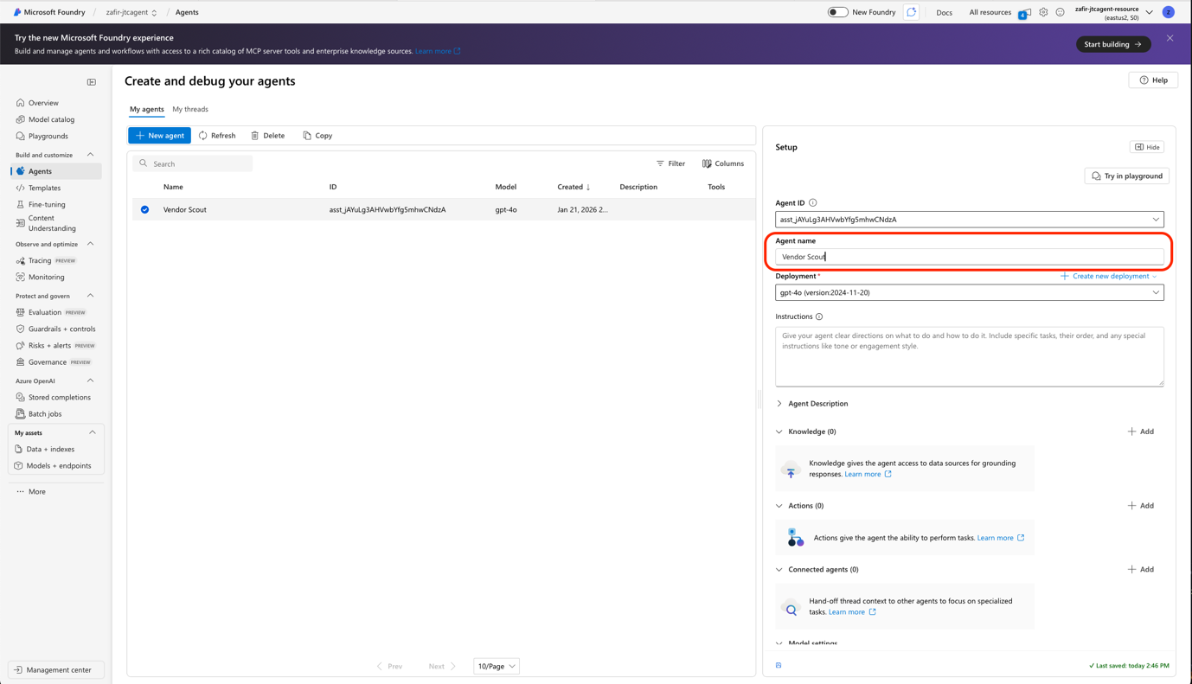

- Great Job! You have set up your foundry resource and deployed the model required for Procurement Command Centre!

